COURSE: DATABASES

ASSIGNMENT 3

STORED PROCEDURES

SQL SERVER MANAGEMENT STUDIO

**Theory part:**

Views and Stored Procedures.

**Practical part:**

A stored procedure is nothing more than prepared SQL code that you save so you can reuse the code over and over again. So if you think about a query that you write over and over again, instead of having to write that query each time you would save it as a stored procedure and then just call the stored procedure to execute the SQL code that you saved as part of the stored procedure.

Before you create a stored procedure you need to know what your end result is, whether you are selecting data, inserting data, etc..

First, create a stored procedure that will just select all the data from the Staff table that is stored in your UpWithSlush database. When creating your stored procedure use first the template provided by the SSMS and then try to build it by using query editor.

Table Staff:

[Id] [int] IDENTITY(1,1) NOT NULL,

[FirstName] [nvarchar](50) NOT NULL,

[FamilyName] [nvarchar](50) NOT NULL,

[Position] [nvarchar](50) NOT NULL,

[Gender] [char](1) NOT NULL,

[DayOfBirth] [datetime] NOT NULL,

[Salary] [decimal](8, 2) NOT NULL

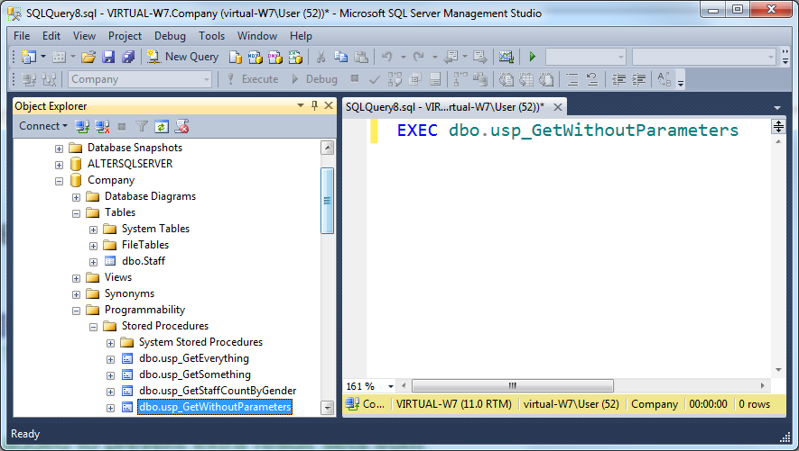

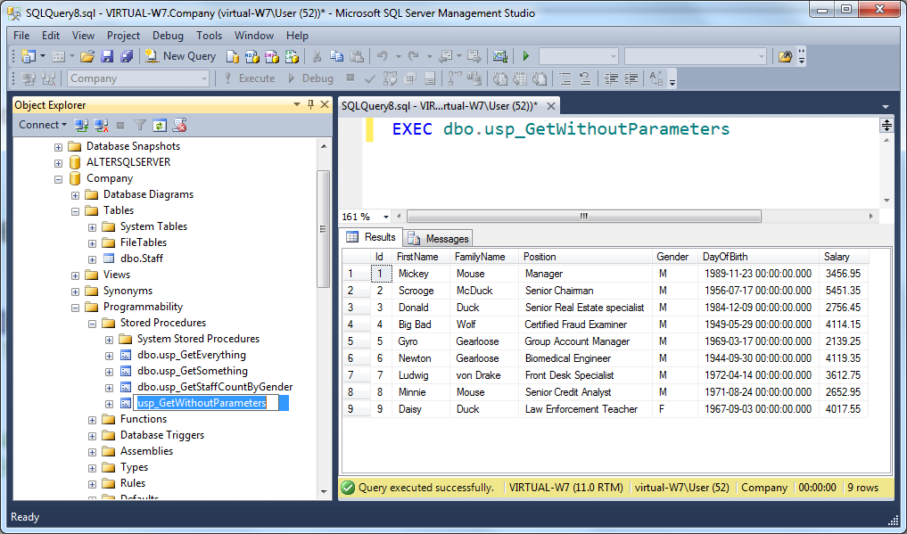

Stored procedure with parameters

The real power of stored procedures is the ability to pass parameters and have the stored procedure handle the differing requests that are made.

In the next task you will query the Staff table from the Company database, but instead of getting back all the records you will limit it to just a particular person. Find the information of a person(s) whose family name is known.

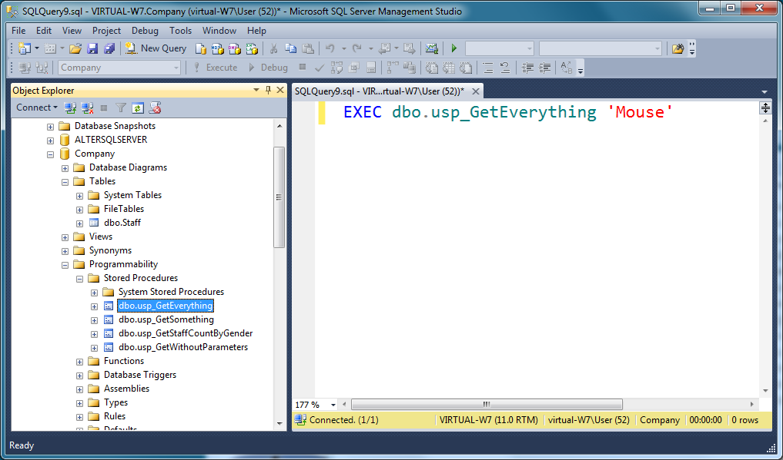

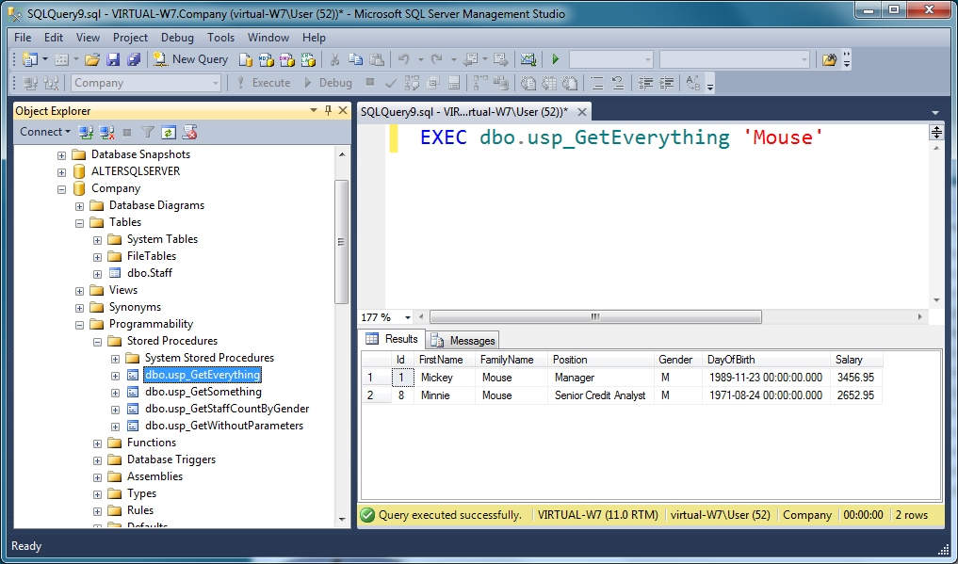

If you want to be a bit more ambitious use LIKE condition in WHERE clause. It is not possible for example to know the complete FamilyName:

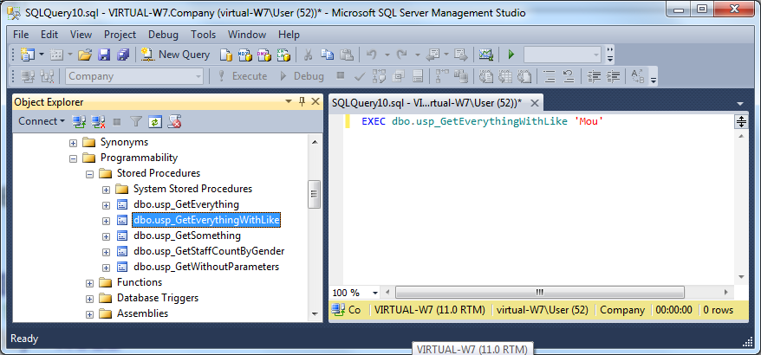

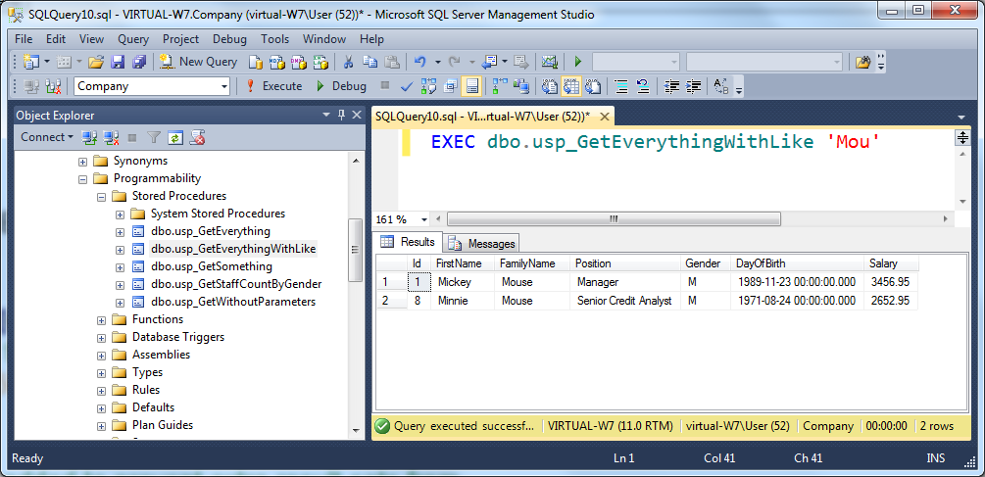

After everything works fine, modify your stored procedure (ALTER) so that it works with default value parameter… or create a new stored procedure for that purpose. This time find out all the information from the Staff having the salary 2500…3500 euros:

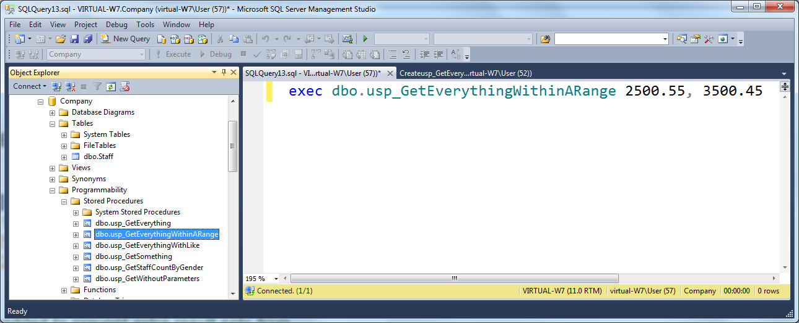

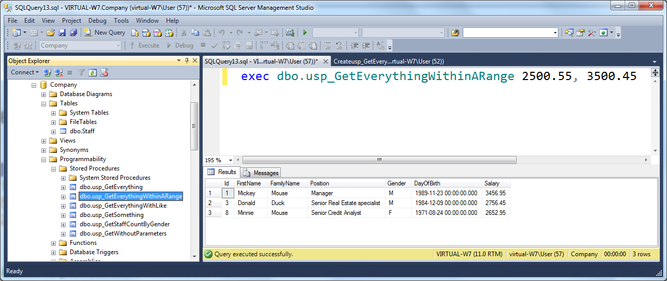

Another example with the same stored procedure (this time you leave out the min value):

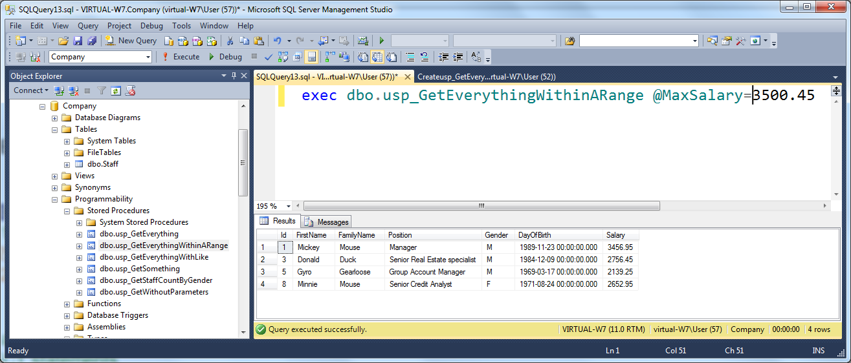

There are two ways of returning result sets or data from a procedure to a calling program: output parameters and return codes.

If you specify the OUTPUT keyword for a parameter in the stored procedure definition, the procedure can return the current value of the parameter to the calling program when the procedure exits. To save the value of the parameter in a variable that can be used in the calling program, the calling program must use the OUTPUT keyword when executing the procedure.

Build stored procedure using an output parameter. How many females are there in the Staff?

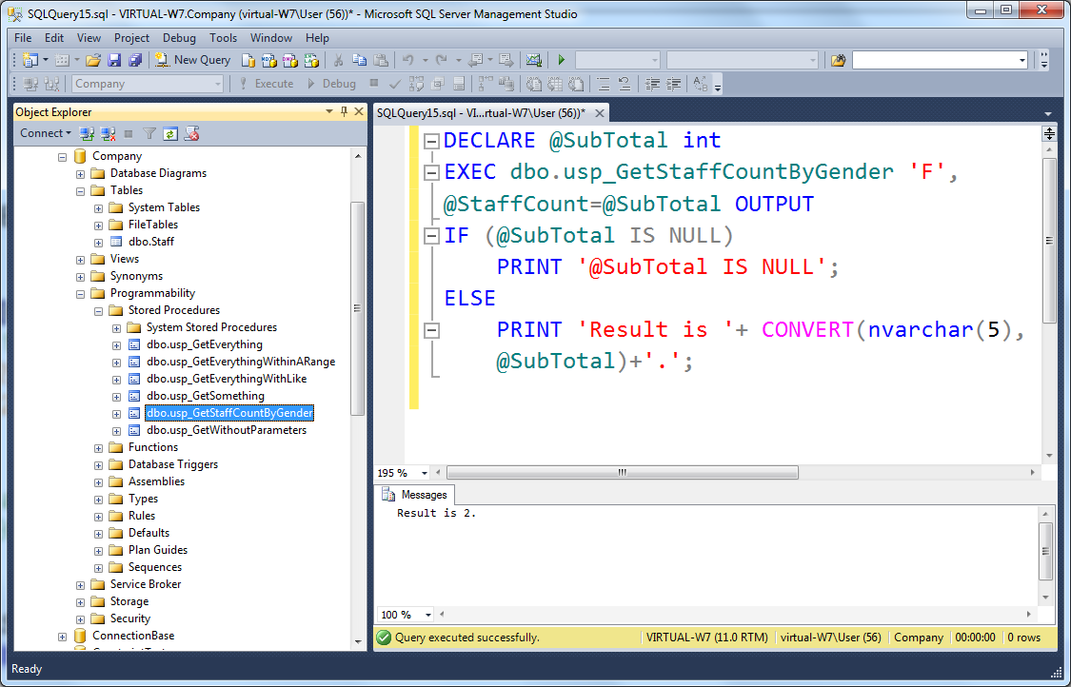

There are some useful system stored procedures.

Study at least sp_help, sp_helptext, and sp_depends system stored procedures.

Build one Word document where you copy and paste all the source code (from the final solution) you have generated during solving the task. Your word document should also show the functional details of the solution. One generic example from functional details: if the task is to make some calculations with the user input, use print screens to show one successful use case where the input is received and calculations will be completed. Your document need not be a complete road map from each individual step, but it should still be understandable and show street credibility to the outside reader. Use exactly the same format you would use with the thesis document (not description sheet, please!), or alternatively use the shorter report template. You can find the instructions from the student intranet.

**Theory part** can be at the beginning of or at the end of your word document where you have your **Practical part**. Remember to add all the references used in your document!

Take your script files together with your Word file and zip it into one file. Return that composite zip file to Moodle.

Assessment: Half from the points come from **Theory part**, another half from **Practical part**.

Submit your task before deadline! It is not possible to return this task

after the deadline.